Installing the Ricoh IM C4500 Printer – Mac OS Instructions

Download the printer driver:
- Download the macOS driver from the web:
https://support.ricoh.com/bb/html/dr_ut_e/rc3/model/imc4500/imc4500.htm
- Select your macOS version and Download. After the download is completed, browse out to Downloads and open Ricoh_IM_C3000_C3500_C4500_LIO_1.8.0.0.dmg Double-click on the file and to mount dmg file.
- Next run Ricoh_IM_C3000_C3500_C4500_LIO_Driver.pkg install file and install the driver.

Add the printer:
- Open System Preferences and Printers & Scanners
- Click "+" under Printers list to add a printer
- In the Add Printer window click IP
- For Protocol: select the LPD option
- For Address: 129.105.102.76
- For Name (for example): Ricoh IM C4500- 129.105.102.76
- For Use (or Print Using): Use the pull-down menu to Select Software…
- In the filter, start typing RICOH IM C4500
- Click Add
- Click OK
- Close Printers & Scanners
Next go back to System Preferences > Printers
Select the Ricoh IM C4500- 129.105.102.76 printer and click on Options and Supplies
Click on the Options Tab and make sure it is configured as the following:
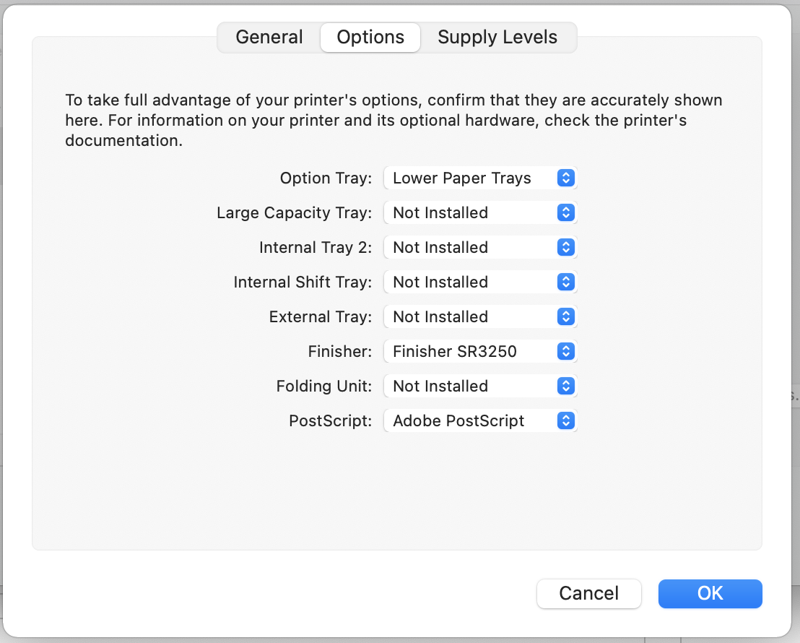
Click OK

