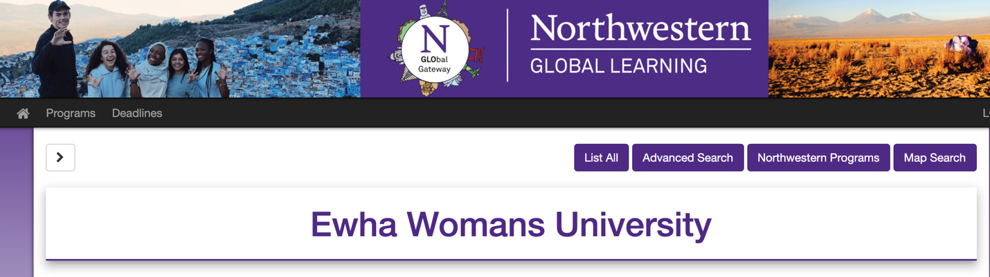

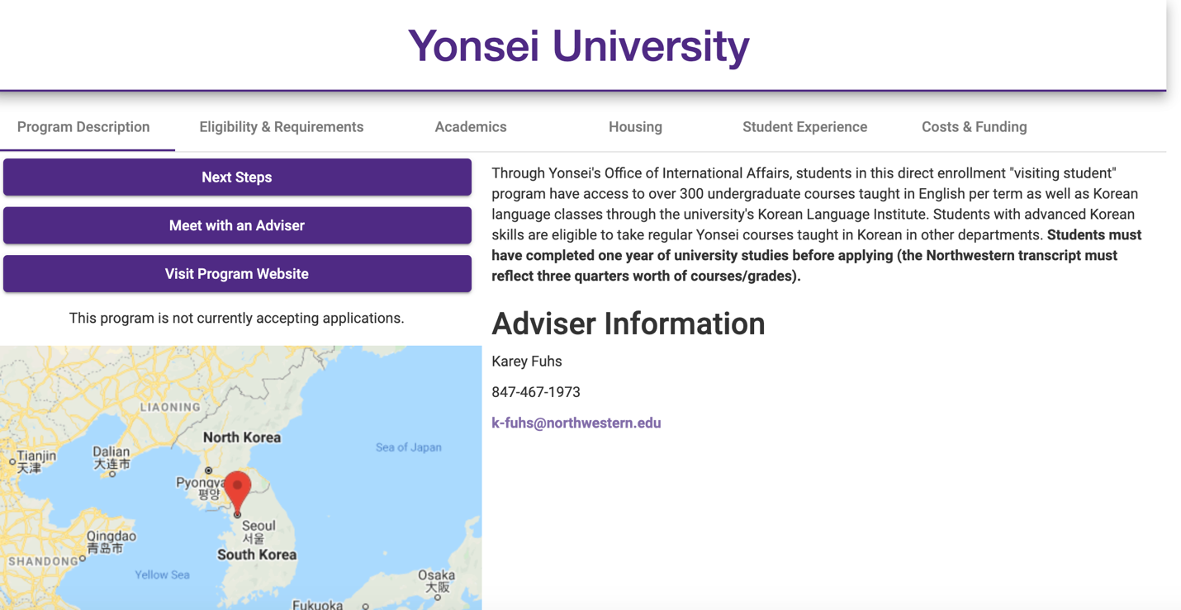

Northwestern has two affiliated schools in South Korea - - Ewha Womans University and Yonsei University.
Please check GLO website for details: https://www.northwestern.edu/abroad/study-abroad/index.html

