Project Description: Thermal system analysis of CSN´s steel coil continuous painting process

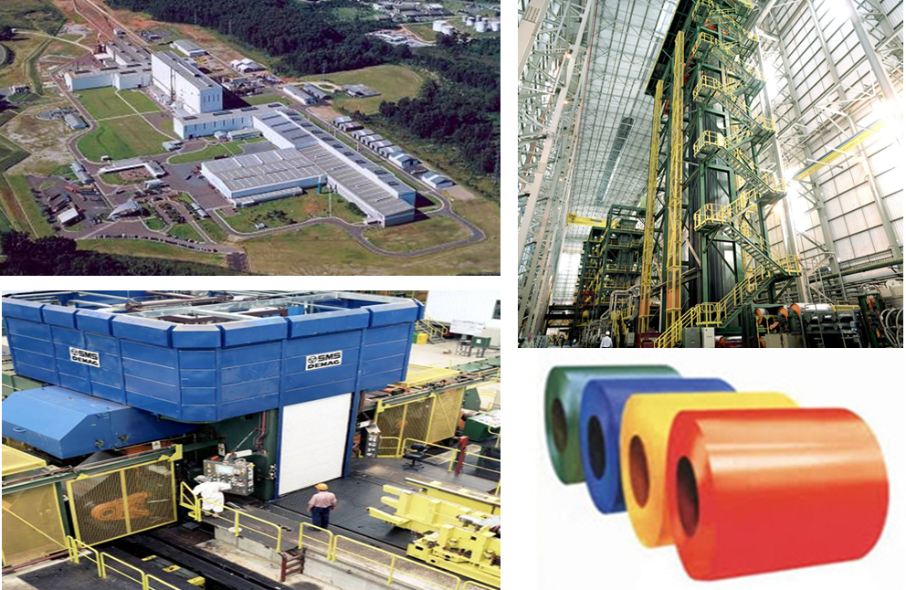

Introduction: CSN painting line has an internal gases capture system where the ink curing occurs to control air emissions (controlled temperatures ~ 230 ° C). This solvent gas is utilized for combustion in order to generate heat used in the painting line preheating process. This is an exothermic burning reaction.

CSN has recently been aware of a new curing infra-red technology. One upside to this technology is the preheating of the combustion air in the production process is no longer required. Only the air blown inside the infra-red curing oven needs to be preheated. However, an equal amount of solvents are burned in this process creating an excessive amount of heat. The excessive amount of heat will require additional cooling efforts, thus more energy.

Project Objective: 1) Compare the energy mass balance of CSN´s current gas oven with a new infra-red technology 2) Identify the best cost benefit of these two options in terms of operational energy costs.

Project Question: Does it make economic sense to migrate to this new technology or should we continue utilizing our current equipment?

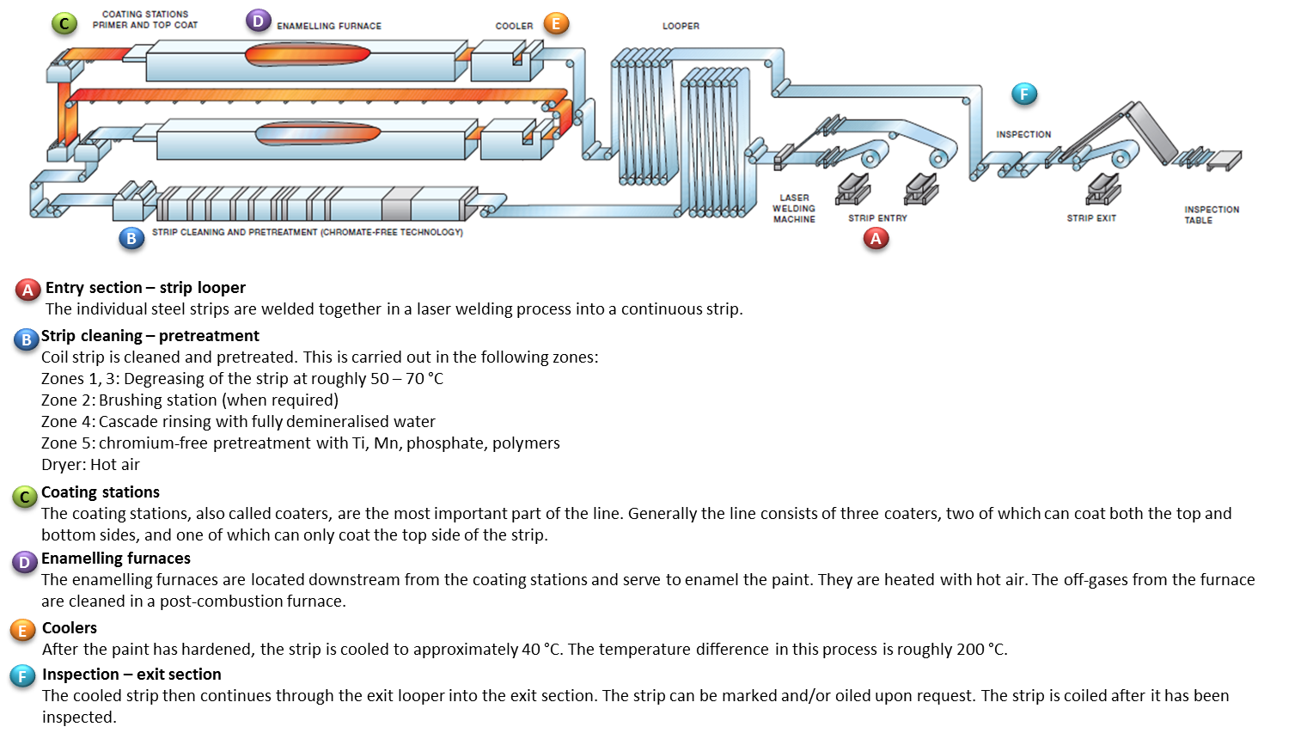

Outcome List:
- Mass Balance Flowchart of Thermal Systems (containing temperatures, flow rates and specific consumption)
- Cost Benefit Comparison of Thermal System

Information provided by CSN:
The current process and mass balance/energy consumption flow chart of Paraná painting line
The technical proposals of the alternative technologies will also be provided

Participants CSN:

Project Sponsor: Christiane Filguiras Machareth Cassimiro- Engineering Project Manager

Project Coordinator: Danielle Maria do Nascimento – Engineering Project Specialist

Project Facilitator-Eric Ballinger

General procedures:

There is no provision physical visit at CSN. The dynamics of the meetings should take place via Skype, video conferencing, telephone conferencing, email or other means of virtual communication. CSN will provide a data room for information exchange.

Governance model:

Structure of project follow-up meetings, defining dates prior to validation points of the steps defined for the project. Students at Northwestern must show a project schedule considering the macro stages of development.

