Updated: 3/3/2016

If you have never registered with CITI and need to create a new account, OR
If you have an existing CITI account that has not been linked with Northwestern via the single sign on method (SSO), please follow the steps below:
- Go to the Collaborative Institutional Training Initiative (CITI) website (www.citiprogram.org).
- Click on the grey “Log in via SSO” button on the right-hand side of the screen.
- A list of institutions will appear. Click on “Northwestern University.”
- A Northwestern University validation screen will come up. Enter your Northwestern NetID and password.
- As part of the account setup, you will be asked if you have an existing CITI account. Provide the requested information.
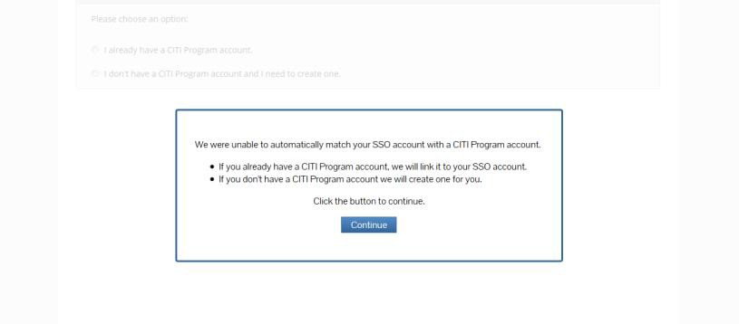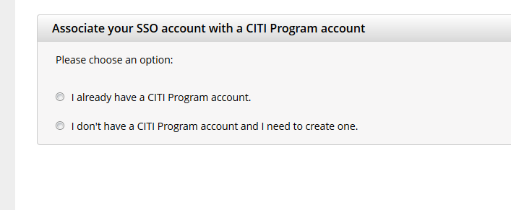
- Under the blue banner labelled “Northwestern University Courses, “select “Add a Course or Update Learner Groups” to select the applicable coursework.
- Your existing account will be affiliated with Northwestern, and you will be able to log in via SSO with your Northwestern NetID and password going forward.

Complete the “RCR course for graduate students and postdocs in McCormick School of Engineering – Basic Course” or the “RCR course for undergraduate students”, as applicable.

If you are unable to log in using the instructions above:
- Send an email that includes the information below to bethirwin@northwestern.edu
  - Put “Problems with SSO” in the subject line of the email
  - Your name, as listed on your CITI account
  - Your CITI username
  - Your CITI account number
  - Your Northwestern NetID

