**Critical Thinking Assessment: Example 1**

**Discipline: Chemical Engineering**

**Created by: Justin Notestein, Northwestern University**

**Funded by: NSF (DUE-0942404)**

The following plots are obtained when a researcher is monitoring the conversion of compound A into compound B as a function of time at a set pressure (left) and for a constant time with increasing pressure (right). The researcher hypothesizes that conversion should increase linearly with time and should be independent of pressure.

% conversion

Time (min)

% conversion

Pressure of A

**Critical Thinking Assessment: Example 2**

**Discipline: Chemical Engineering**

**Created by: Justin Notestein, Northwestern University**

**Funded by: NSF (DUE-0942404)**

You are an engineer at Dow Chemical looking to make a new product by one of two processes A and B described in patents and summarized below. Both processes use the same reactants, have the same products, and generate the same overall yields.

Reactant

Product

Byproduct

20 m tall separator

T = 200°C

P = 50 psig

**Process A: Patent 1,234,567, year 1978**

100 m3 reactor

T = 200°C

P = 50 psig

Reactant

Product

Byproduct

compact separator

T = 200°C

P = 500 psig

**Process B: Patent 4,567,890, year 2010**

1 m3 reactor

Filled with catalyst

T = 200°C

P = 500 psig

Additional info:

* The reactant is toxic.
* Compressors are expensive to operate due to electricity costs.
* Temperatures above 150°C require special materials of construction.
* The catalyst and compact separator units are proprietary (separately patented and licensed)
* 12 examples of process A have been built at this scale; no examples of process B have been built at this scale.
* The product is worth $1200/ton
* The reactant costs $800/ton

To help you decide between the two processes, you hire a consultant with many decades of experience. For two processes that have the same overall specifications (use the same reactants, generate the same products), the major deciding factor for Dow will be total cost to build and operate the process.

**Critical Thinking Assessment: Example 3**

**Discipline: Neurobiology, Linguistics, Communication Sciences and Disorders, Psychology**

**Created by: Denise Drane, Northwestern University**

**Funded by: NSF (DUE-0942404)**

Specific language impairment (SLI) is a type of language impairment that affects children’s vocabulary and grammatical development. Children with SLI are not developmentally delayed and do not have autism. They have poor vocabulary development and make many grammatical errors. The cause of SLI is unknown. Some researchers have hypothesized that SLI is due to an abnormality in part of the brain called the planum temporale. Below is a table showing data on of the density of the cortex in planum temporale in children with SLI and normal control children who do not have SLI.

|  |  |  |
| --- | --- | --- |
| SLI | Normal Controls | p-value |
| 2 x 106 cells per inch | 8 x 106 cells per inch | 0.00003 |

**Critical Thinking Assessment: Example 4**

**Discipline: Chemistry**

**Created by: Cornelia Forrester, City Colleges of Chicago**

**Funded by: NSF (DUE-0942404)**

* The Chart below shows the variation in atomic radius as we go from row 2 to row 5 of the elements in group one on the periodic table. Review the chart below and answer the following questions

Figure 1: Showing the atomic radius for elements in Group one as we go from row 2 to row 5 elements

**Critical Thinking Assessment: Example 5**

**Discipline: Physical Sciences**

**Created by: Eric Fucco, City Colleges of Chicago**

**Funded by: NSF (DUE-0942404)**

**Scenario 1:** With the increased awareness of global warming, scientists have been studying nitrogen oxides (NOx) in the atmosphere. NOx is a common byproduct of combustion reactions that can occur in automobiles, composting, factory emissions, and waste water treatment. The graph below reflects nitrogen oxide concentrations in the atmosphere during a typical weekday in Chicago. A 24-hour clock is where 1 = 1 a.m., 12 = noon, 13 = 1 p.m., and 24 = midnight.



**Critical Thinking Assessment: Example 6**

**Discipline: Chemical Engineering**

**Created by Suzan Van der Lee, Northwestern University**

**Funded by: NSF (DUE-0942404)**

Xx

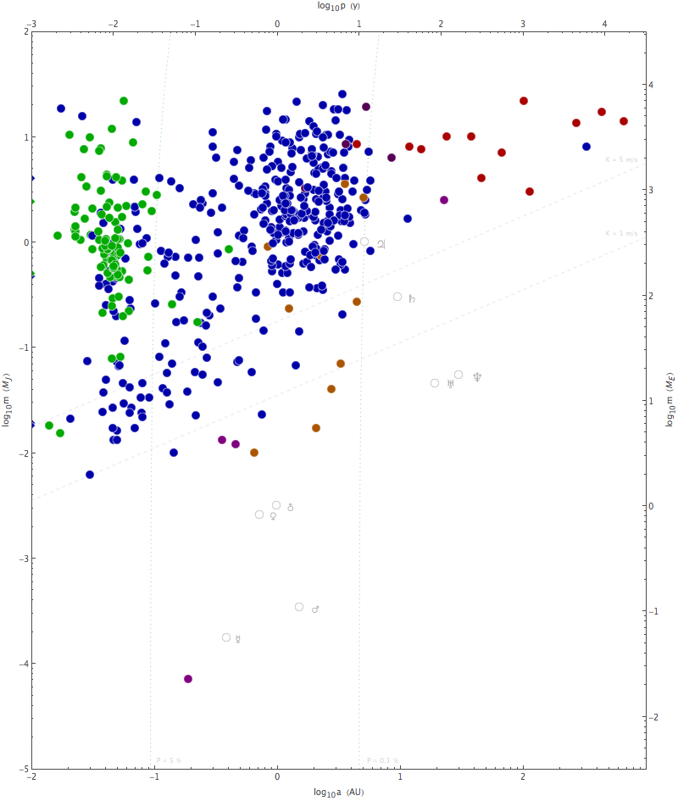

mass [MJ]

10

1

0.1

0.01

0.001

0.01 0.1 1 10 100 1,000 10,000

orbital period [y]

Exosolar Planets

Exosolar planets are planets that revolve around a star that is not our Sun. The path of one revolution around the star (or Sun) is called an orbit and the time it takes to complete one orbit is called the orbital period. In the graph, orbital period is measured in years [y] and mass is given as a factor to multiply with the mass of Jupiter [MJ].

When exosolar planets pass between us and the star they are orbiting, they diminish the star’s brightness or otherwise affect the star’s appearance by a tiny amount. These tiny amounts can be detected by very sensitive telescopes and other sophisticated astronomical instruments, especially when the phenomenon is confirmed with each of several completed orbits. The number of detected exosolar planets has been growing progressively since the 1995 discovery by Geneva-based astronomers of an exoplanet orbiting the star 51 Pegasi. Since then, more than 700 exoplanets have been discovered within 300 lightyears of us, which represents one thousandth of one percent of our Milky Way galaxy. In order to identify planets that could be like Earth and habitable, the mass (in number of Jupiter masses) and orbital period (in years) of each detected exosolar planet is graphed with a colored dot. The different colors represent different detection methods, with the green dots representing the mentioned method of measuring the diminished star brightness when the planet passes in front of it, the blue representing a more sophisticated method, and red-brown dots having been found with the most sophisticated method. The faint grey symbols in the graph represent planets from our own solar system. For a planet to be habitable it must be solid (rather than a gas giant) and not be too far or too close to its star.

**Critical Thinking Assessment: Example 7**

**Discipline: Neurobiology, Linguistics, Communication Sciences and Disorders, Psychology**

**Created by: Denise Drane, Northwestern University**

**Funded by: NSF (DUE-0942404)**

Makers of the Happy Bee language stimulation video claim that there video is a highly effective treatment method for children with language disorders and who have very small vocabularies. To support their claim, on their website they provide the following data on vocabulary growth of the 3 year old children who use over a 12 month period. Data are based on 1000 children.

|  |  |
| --- | --- |
| January 2010 | December 2010 |
| 55 words | 105 words |