- Select the Crop tool from the left pane:
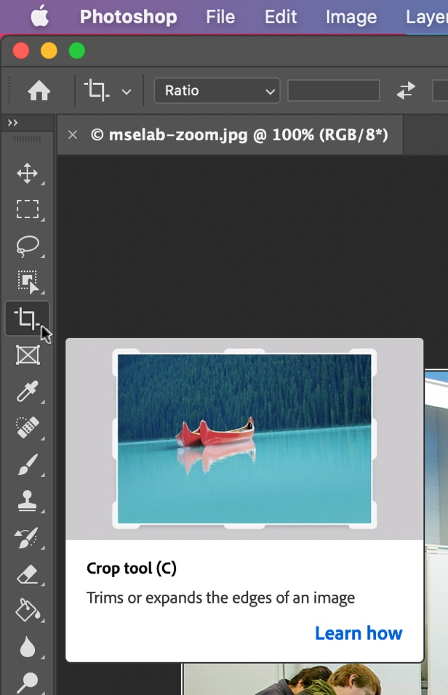

- Once the top toolbar updates for cropping, select W x H x Resolution from the dropdown menu that appears.
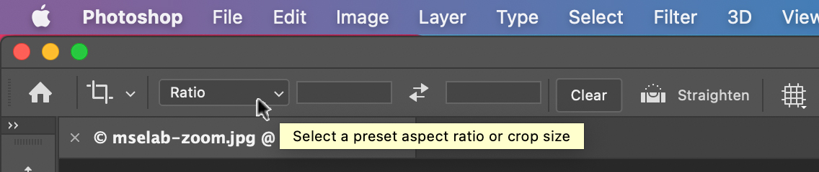

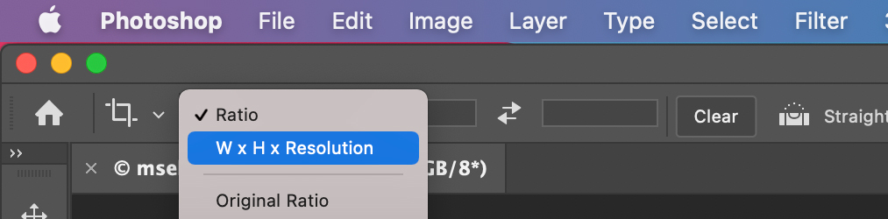

- Enter the desired image width (including px for pixels) in the first input field and height (including px) in the second field. Enter 72 for the resolution in the third field.

- A cropping window will appear over the image, which can be adjusted by dragging from any edge. Never move outside the images boundary. Also, adjust the image within the cropping window by holding a right click of the image while moving your mouse to drag it to a different position.
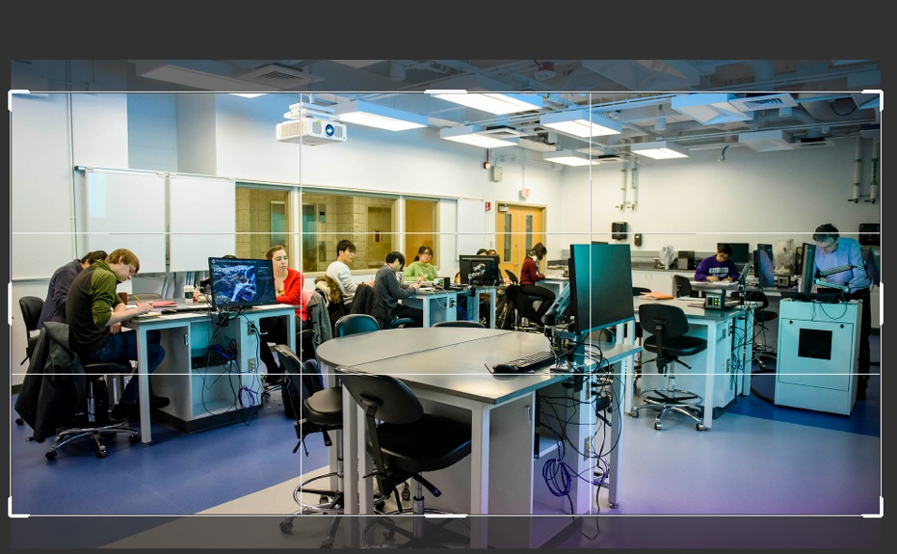

- Once the view of the image within the cropping window is satisfactory, click Enter to crop the image.

- Then Go to File > Save for Web to save the image*. JPG or PNG is fine. Quality in the top right corner should be between 70 and 80 percent**.
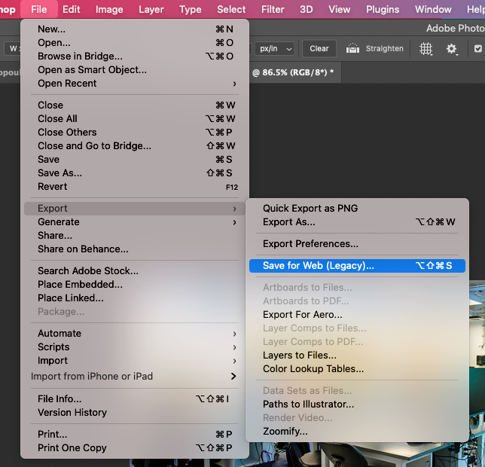
*Note: The “Save for Web” option might appear right in the File menu, depending on which Photoshop version you have.

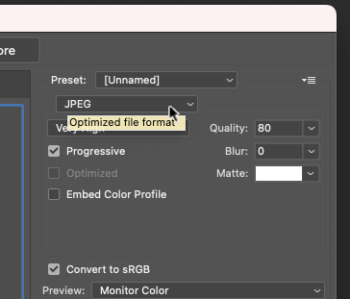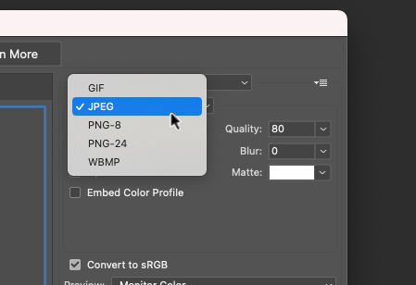
**Note: The “Quality” asset won’t display in the top right of the “Save to Web” window unless the image is a JPEG or PNG. Click the drop-down menu to change the image to JPEG/ PNG if that is not the default option

Click Save at the bottom of the window to name the file and store on your computer.

