A Whole-Brain Undergraduate Education
“Whole-brain engineering” is the core of a McCormick education. Engineering is grounded in analysis, logic, synthesis, and math — all considered elements of “left-brain” or convergent thinking. “Left-brain” skills are essential in engineering, but to prosper in this rapidly changing world, another high-level thinking skill is needed: “right-brain” or divergent thinking — intuition, metaphor, and creativity. To be leaders, students must master both kinds of thinking.
McCormick’s whole-brain approach has led to remarkable increases in undergraduate admission. Since 2005, applications to McCormick have increased nearly 150 percent. The number of female engineering students has risen 30 percent over that time, and we have seen growth in every underrepresented minority group.
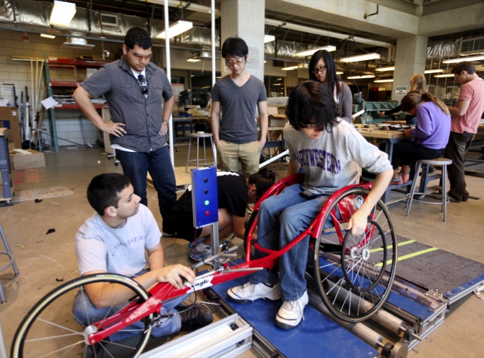
In the Classroom
We have a long history of offering innovative and dynamic academic opportunities at McCormick. The quarter system enables students to take at least 48 courses in four years, as opposed to 32 in a typical semester system. This allows students to combine areas of study in flexible ways – students can take nearly a third of their courses in the humanities, if they wish.
A flexible curriculum also requires flexible spaces. Traditional lecture halls are giving way to increased studio space, collaborative work areas, and prototyping facilities. McCormick is also developing initiatives that require no space at all, harnessing the potential of online education to augment the student experience.
Through Design Thinking and Communication, every first-year student works on at least one project for a client with a disability, many in partnership with the Rehabilitation Institute of Chicago.
McCormick courses are at the frontier of engineering education. Design Thinking and Communication (DTC) is part of Engineering First, the innovative first-year curriculum for McCormick undergraduates. Students work with real clients to solve problems, such as designing a corkscrew for people with arthritis. DTC is team-taught by faculty from McCormick and the Weinberg College of Arts and Sciences Writing Program.
Following DTC, students have opportunities for experiential learning throughout the curriculum. In upper-level design studios, students learn to meet the needs of corporate and nonprofit partners. In departmental capstone courses, students work with clients around the world to apply their expertise.
NUvention is a groundbreaking course series created by McCormick that assembles cross-school teams to invent a product or service and launch a business. It was named a “best course” by Inc. magazine in 2011. Several startups that began in the courses have flourished, including two from NUvention: Web. Groovebug is an iPad app that creates an interactive magazine based on a person’s music library, and SweetPerk builds mobile apps for local stores to reach shoppers.

Undergraduate:
- Continued implementation of the McCormick Advising System, including enhancements to online advising software, evaluation of faculty advising system for upperclass students, and ongoing refinement of new first-year advising process
- Admission numbers continue on a positive trajectory. Of particular note is the increase in yield among highly desirable students, such as the Murphy Institute Scholars (hand selected by key faculty)
- Continued development of Personal Development program, with course on Emotional Intelligence (co-taught with CAPS) drawing significant attention
- Ongoing alignment and coordination of McCormick Career Development with Career Advancement
- Support of new interdisciplinary courses, such as “Analytics for Social Good,” which includes students from all undergraduate schools
Lorem Ipsum Dolor
The best students in the country are choosing a whole-brain education at McCormick. To help these students meet the needs of tomorrow, we must ensure that our curriculum is dynamic and collaborative as boundaries between academic disciplines blur; we must assist each student in finding his or her best path amid abundant opportunities; and we must prepare students for a lifetime of leadership and impact.
Graduate:
- Continued successful focus on increasing URM and female numbers among doctoral students. Of the US News Top 25, Northwestern has the second highest percentage of female PhD students (29.2%) and the third highest percentage of URM students (18.9% of domestic students)
- McCormick IT continues development of GATS and GSTS
- Successful launch of new MS in Robotics
- Increased attention to professional MS programs, including the addition of a marketing strategist to align current marketing efforts and more efficiently promote programs
Leadership and Faculty:
- New chairs for BME (Perreault) and ESAM (Chopp); upcoming change in CEE (Jianmin Qu named dean at Tufts)
- Transition of Corporate Relations from Chip Hay to Giorgio Bortolotto

