Deep Learning for Biomedical Imaging

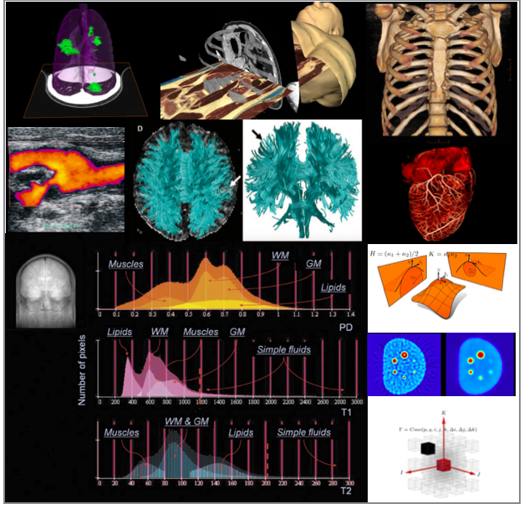
Course Description: Imaging science is experiencing tremendous growth. The New York Times recently ranked biomedical engineering jobs as the number one fastest growing career field in the nation and listed biomedical imaging as a primary reason for the growth. Medical imaging (as a core component of biomedical imaging) and its analysis are fundamental to understanding, visualizing, and quantifying medical images in clinical applications. With the help of automated and quantitative image analysis techniques, disease diagnosis will be easier/faster and more accurate, leading to significant development in medicine in general.
The department of BME, in conjunction with Machine and Hybrid Intelligence Lab of Radiology, offers this timely course to introduce medical image analysis with deep learning techniques. Students will learn how to apply deep learning algorithms to analyze and interpret medical images such as X-rays, CT scans, and MRI scans. The course will cover basic image processing techniques, the fundamentals of deep learning, and their applications in medical image analysis.

Course Objectives:
- Understand the basic concepts of medical image analysis and deep learning.
- Develop practical skills for using deep learning techniques for medical image analysis.
- Understand how deep learning algorithms can be applied to real-world medical image analysis problems.
- Be able to implement deep learning algorithms using open-source libraries such as PyTorch.
- Learn how to evaluate and validate the performance of deep learning algorithms in medical image analysis.
Course Instructor:
Ulas Bagci, Ph.D.,
Associate Professor,
Director of Machine & Hybrid Intelligence Lab,
Department of Radiology, Feinberg School of Medicine,
Department of Biomedical Engineering (Courtesy),
Department of Electrical and Computer Engineering (Courtesy),
Northwestern University, 737 N. Michigan Avenue Suite 1600,
Machine & Hybrid Intelligence Lab

Chicago, IL 60611, USA
Phone: +1 312-694-4951
Web: www.bagcilab.com

Class meetings:
Each week has two lectures, each lecture has 80 minutes class time.

I. Introduction to Medical Imaging & Analysis (Lectures 1 and 2)
- Overview of medical image analysis and its importance in healthcare
- Types of medical images (X-rays, CT scans, MRI scans, etc.)
- Challenges in medical image analysis
- Overview of deep learning and its applications in medical image analysis

II. Image Processing Techniques (Lectures 3 and 4)
- Image preprocessing (noise reduction, normalization, etc.) (Lecture 3)
- Image segmentation (thresholding, clustering, region growing, etc.) (Lecture 4)
- Feature extraction (texture analysis, radiomics, etc.) (Lecture 4)

III. Fundamentals of Deep Learning (Lectures 5-to-9)
- Artificial Neural Networks (Lecture 5)
- Convolutional Neural Networks (CNNs) (Lecture 5)
- Recurrent Neural Networks (RNNs) (Lecture 6)
- Capsules (Lecture 6)
- Transformers (Lecture 7)
  - Self-attention mechanism
  - Multi-head attention
  - Other Transformer architectures (e.g., BERT, GPT)
- Generative Algorithms (Lectures 8 and 9)
  - Generative Adversarial Networks (GANs) (Lecture 8)
  - Variational Autoencoders (VAEs) (Lecture 8)
  - Diffusion Models (Lecture 9)

IV. Implementing Deep Learning Algorithms and Practice (Lectures 10-to-12)
- Deep learning libraries (PyTorch, etc.) (Lecture 10)
- Building and training deep learning models (Lecture 10)
- Model optimization (hyperparameter tuning, regularization, etc.) (Lecture 10)
- Performance Evaluation and Validation (Lecture 11)
- Evaluation metrics (accuracy, sensitivity, specificity, etc.) (Lecture 11)
- Cross-validation techniques (Lecture 11)
- Interpreting model outputs (Lecture 12)
- Visual Explanations (Lecture 12)

V. Applications of Deep Learning in Medical Image Analysis (Lectures 13-to-17)
- Image classification (disease diagnosis, anomaly detection, etc.) (Lecture 13)
  - Application example: X-ray classification
  - Application example: Anomaly detection in brain scans
  - Application example: Pancreas pathology detection/diagnosis
- Image segmentation (tumor detection, organ segmentation, etc.) (Lectures 14 and 15)
  - U-Net and Tiramisu
  - nn-U-Net
  - Hybrid methods: Transformer + U-Net
- Object detection (finding objects of interest, such as cancerous tumors) (Lecture 16)
  - Application example: Lung tumor localization
  - Application example: Liver tumor localization
- Image generation (generating synthetic medical images for training) (Lecture 17)
  - Application example: Use of GAN (and its variants) for image generation

VI. Future Directions in Medical Image Analysis (Lecture 18)
- Overview of current research in medical image analysis
- Emerging trends in deep learning and medical image analysis

VII. Student Project Presentations (Lectures 19 and 20)
Medical imaging plays a crucial role in the diagnosis and treatment of many medical conditions. However, interpreting medical images can be challenging, and requires significant expertise and experience. This is where deep learning can play a critical role. Students are expected to present their projects in the classroom after submitting their results and source code. Images will be from publicly available sources.

Assessment and Grading:
Assignments: 45% (15% for each assignment, a total of 3 assignments)
Final project: 55% (15% innovation, 20% approach, 10% results and evaluations, 10% presentation)
Grading will be determined based on the total points earned in above categories.
Greater than or equal to 90%: A
Between 85-89.9%: A-
Between 80-84.9%: B+
Between 75-79.9%: B
Between 70-74.9%: B-
Between 65-69.9%: C+
Between 60-64.9%: C
Between 50-59.9%: D
Below 50: F
Grading may be adjusted based on the skewed distribution of the grades.

Final projects to choose from:
(1) Automatic disease detection/diagnosis,
(2) Automatic segmentation of organs and/or pathologies,
(3) Synthesize medical images with deep generative learning.

Prerequisites:
The course is designed for graduate students, but undergraduate students are welcomed to take the course too. The following prerequisites are determined:
- Basic knowledge of programming (Python)
- Basic knowledge of linear algebra and calculus
- Basic knowledge of image processing and machine learning is preferred.

Text:
Course lecture notes/powerpoints are the main source for the course.
The following books are optional to read/study:
- Image Processing, Analysis, and Machine Vision. M. Sonka, V., Hlavac, R. Boyle. Nelson Engineering, 2014.
- Medical Imaging Signals and Systems, Jerry Prince & Jonathan Links, Publisher: Prentice Hall.
- Deep Learning, Goodfellow Ian, Bengio Yoshua, and Courville Aaron, 2016, Freely available, MIT Press.

